

**Faculty of Engineering & Technology - B.Tech**

PROJECT NAME

|  |  |
| --- | --- |
| **Name** | **Enrollment Number** |
| Yuval Panchal | 202202626010073 |
| Ayush Nikose | 202202626010072 |
| Aashka Patel | 202202626010076 |

**VISION WALK**

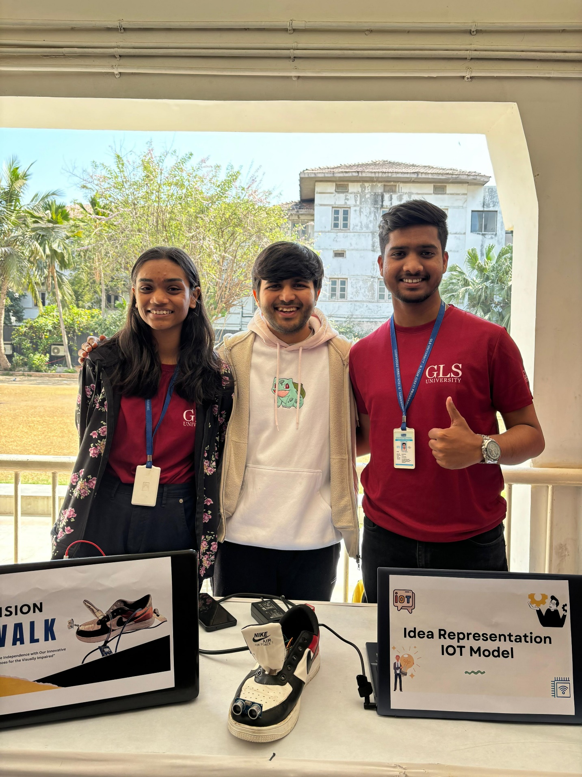

**Index**

* Introduction
* Key Objectives
* Component Used
* Components Description
* Features
* Drawbacks
* Exceptions
* Circuit Diagram
* Project Images
* Conclusion

**Introduction**

Smart blind shoes with GPS tracking system are cutting-edge footwear designed to revolutionize the mobility and safety of visually impaired individuals. These technologically advanced shoes integrate GPS tracking capabilities, allowing users to navigate their surroundings confidently and independently. Equipped with sensors and advanced navigation algorithms, these shoes provide real-time feedback to users, helping them avoid obstacles and navigate unfamiliar environments with ease. By leveraging GPS technology, smart blind shoes offer unparalleled freedom of movement, enhancing the mobility and quality of life for individuals with visual impairments.

Imagine a pair of shoes that not only serve as a means of transportation but also act as a personal navigator for the visually impaired. Smart blind shoes with GPS tracking system embody this vision by combining innovative technology with everyday footwear. With embedded GPS modules and intelligent sensors, these shoes provide users with precise location information and audible directions, empowering them to traverse streets, sidewalks, and public spaces with confidence and autonomy. Seamlessly blending functionality and style, smart blind shoes represent a groundbreaking solution that promotes independence, safety, and accessibility for individuals with visual impairments in an increasingly interconnected world.

**Key Objectives**

The primary goal for smart shoes designed for blind people is to enhance their mobility, independence, and safety while navigating the outdoors and indoors. These innovative footwear solutions integrate technology to provide tactile feedback, obstacle detection, and navigation assistance, aiming to transform how visually impaired individuals perceive and interact with their surroundings. Below is a descriptive overview of the objectives and features of smart shoes for blind people:

Enhanced Navigation and Mobility :

Smart shoes for the visually impaired are equipped with sensors and GPS technology to detect obstacles and provide real-time navigation assistance. They can guide users around obstacles and through unfamiliar environments, significantly improving their ability to move freely and safely.

Obstacle Detection :

Equipped with ultrasonic sensors, vibration motors, or other haptic feedback mechanisms, these shoes can detect obstacles in the wearer's path. When an object is detected, the shoes alert the user through vibrations or auditory signals, allowing them to avoid obstacles and navigate spaces more confidently.

Safety Features :

Safety is a paramount concern, and these shoes often include features designed to protect the user. This can range from LED lights for visibility to emergency alerts that can be activated in distress situations. The goal is to ensure the wearer's safety in various environments, from busy city streets to quieter, more unpredictable terrains.

In conclusion, the primary goal of smart shoes for blind people is to provide a sophisticated, user-friendly mobility aid that enhances their independence, safety, and quality of life. Through the integration of advanced technology and thoughtful design, these shoes represent a significant step forward in accessibility and support for visually impaired individuals, offering them new opportunities to navigate the world with confidence.

**Component Used**

* Arduino UNO
* Jumper wire
* Ultrasonic Sensor
* Led
* GPS Tracking Device
* Shoes
* USB to Arduino Cable
* Buzzer

**Component Description**

* Arduino UNO:

The Arduino UNO stands as a multifaceted microcontroller board, serving as the central processing unit for various electronic endeavors. Boasting both input and output pins, along with a convenient USB connection for programming, it seamlessly interfaces with an extensive array of sensors and modules. Its intuitive interface and open-source design render the Arduino UNO an optimal selection for novices and seasoned creators alike, fostering the development of interactive and programmable gadgets with unparalleled ease.

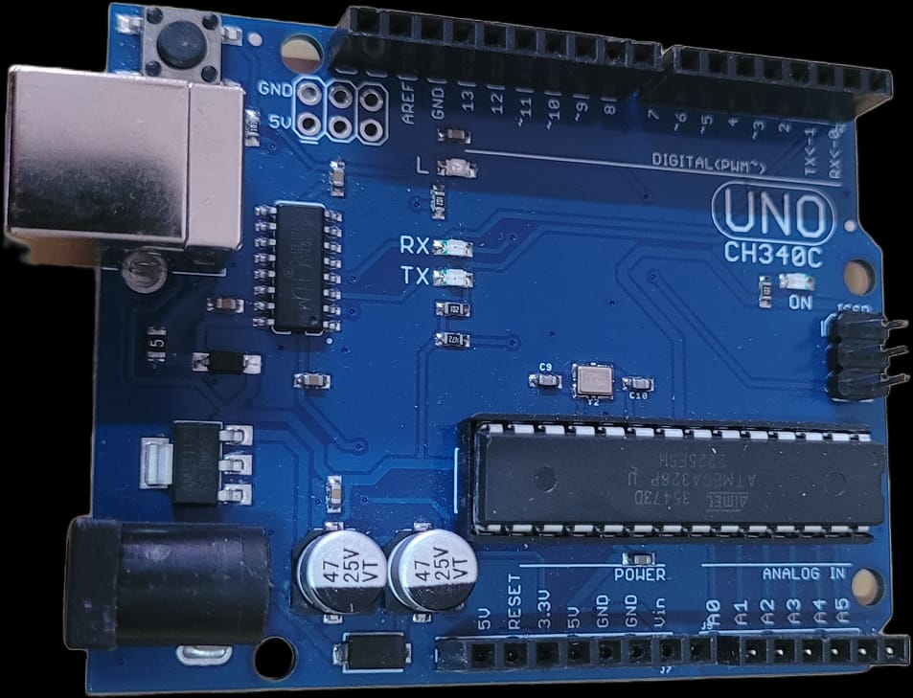

* Jumper Wire:

Jumper wires serve as indispensable elements in electronics projects, facilitating connections between components on a breadboard or across diverse modules. Their flexibility and plug-and-play design enable effortless signal and power transfer, ensuring tidy and structured electrical connections without the necessity of soldering.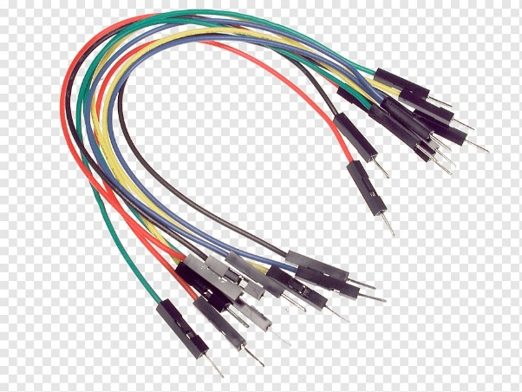

* **Ultrasonic sensor :**

An ultrasonic sensor is an instrument that measures the distance to an object using ultrasonic sound waves. An ultrasonic sensor uses a transducer to send and receive ultrasonic pulses that relay back information about an object's proximity.

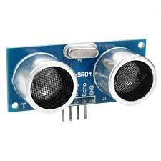

* **GPS Sensor (Global Positioning System) :**

GPS sensors are receivers with antennas that use a satellite-based navigation system with a network of 24 satellites in orbit around the earth to provide position, velocity, and timing information.

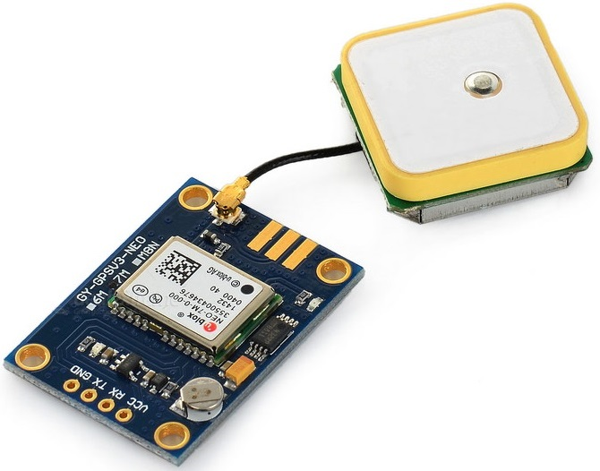

* **Shoe :**

A shoe is an item of footwear intended to protect and comfort the human foot. Though the human foot can adapt to varied terrains and climate conditions, it is vulnerable, and shoes provide protection.

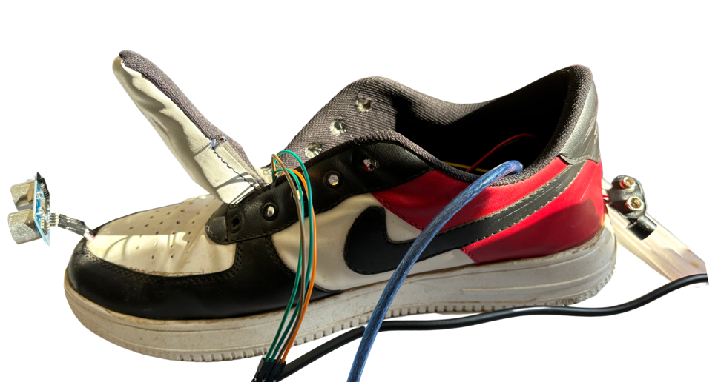

* USB Cable:

A USB cable acts as the conduit linking the Arduino UNO board to a computer, facilitating programming and power supply. This connection permits data transfer, empowering users to upload code to the Arduino while powering the board concurrently. In Arduino projects, USB cables featuring Type-A and Type-B connectors are prevalent, ensuring smooth connectivity and communication.

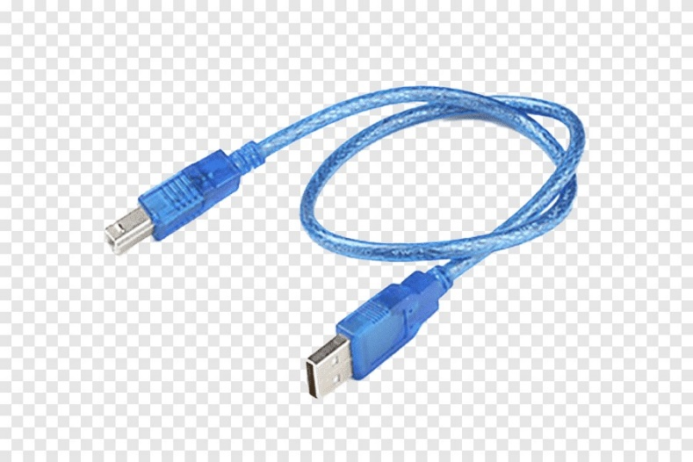

* **Buzzer :**

A piezo buzzer is a type of electronic device that's used to produce a tone, alarm or sound. It's lightweight with a simple construction, and it's typically a low-cost product.

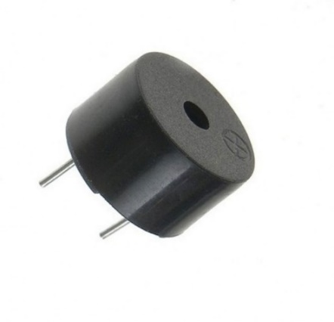

* **Battery :**

**A battery is a device that converts chemical energy contained within its active materials directly into electric energy by means of an electrochemical oxidation-reduction (redox) reaction.**

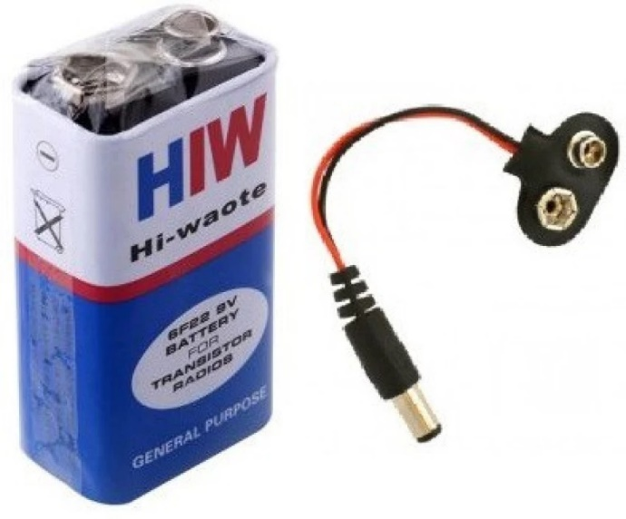

**Features**

1. Obstacle Detection:

Equipped with sensors, these shoes can detect obstacles in the wearer's path, reducing the risk of accidents and injuries.

1. Real-time Feedback:

Through audio cues, or other haptic feedback, users receive immediate information about their environment, aiding in safer and more confident navigation.

1. Self-reliance:

With the ability to navigate more safely and effectively, users can travel independently, reducing their reliance on others for assistance.

1. Emergency Features:

Some smart shoes include features like GPS tracking and SOS signals, allowing users to share their location with caregivers or emergency services if needed.

1. Confidence Boost:

The enhanced mobility and safety features of smart shoes can significantly boost the confidence of visually impaired users, encouraging them to engage more actively with their surroundings.

1. Comfort and Usability:

Designed with the needs of visually impaired users in mind, these shoes often prioritize comfort for extended wear and ease of use in their operation.

**Drawbacks**

1. Battery Discharge :

* Limited Battery Life : Ultrasonic sensors and Arduinos, especially when actively sensing and processing data, can consume significant amounts of power. This can lead to a relatively short battery life, especially if the device is used frequently or for extended periods.
* Potential Malfunction : As the battery discharges, the performance of the ultrasonic sensor and Arduino may degrade. This can lead to unreliable or inaccurate measurements, affecting the functionality of the device
* Maintenance Requirements : Regular maintenance checks may be needed to ensure the battery is functioning properly and to detect any issues early on. Failure to do so could result in unexpected shutdowns or malfunctions during use.

1. Environmental Limitations :

* Ultrasonic sensors can be affected by environmental factors such as extreme temperatures, humidity, and atmospheric conditions. Harsh weather conditions like heavy rain, snow, or fog can interfere with the accuracy and reliability of the sensor readings, making it less effective in such conditions.
* Surface Dependency: The performance of ultrasonic sensors can vary depending on the surface they are detecting. For instance, uneven or irregular surfaces, highly reflective surfaces, or surfaces with soft or absorbent materials may cause inaccurate readings or detection errors.
* Limited Indoor Navigation: While ultrasonic sensors can be effective for obstacle detection in outdoor environments, they may encounter challenges when used for indoor navigation. This is because indoor spaces often contain various obstacles such as furniture, walls, and doorways, which may not be effectively detected or navigated using ultrasonic sensors alone.

1. One-Size-Fits-All Approach :

* The design of smart shoes may not accommodate all types of disabilities or the specific needs of every user, limiting their usefulness for some individuals.Technology Access: Users in areas with limited access to technology, or those who cannot afford the latest gadgets, might find it difficult to benefit from smart shoes.

**Exceptions**

1. Integration with Other Technologies :

Integrating smart shoes with other assistive technologies (like smart canes or navigation apps) to provide a more comprehensive solution can be complex but is necessary for maximizing user independence.

1. Regulatory and Compliance Issues :

Meeting regulatory standards and compliance requirements, especially in different countries, can complicate the development and distribution of smart shoes.

1. Training and Support :

Providing adequate training for users to get the most out of the technology, along with ongoing support to address issues and updates, is essential for user satisfaction and long-term success.

**Circuit Diagram**

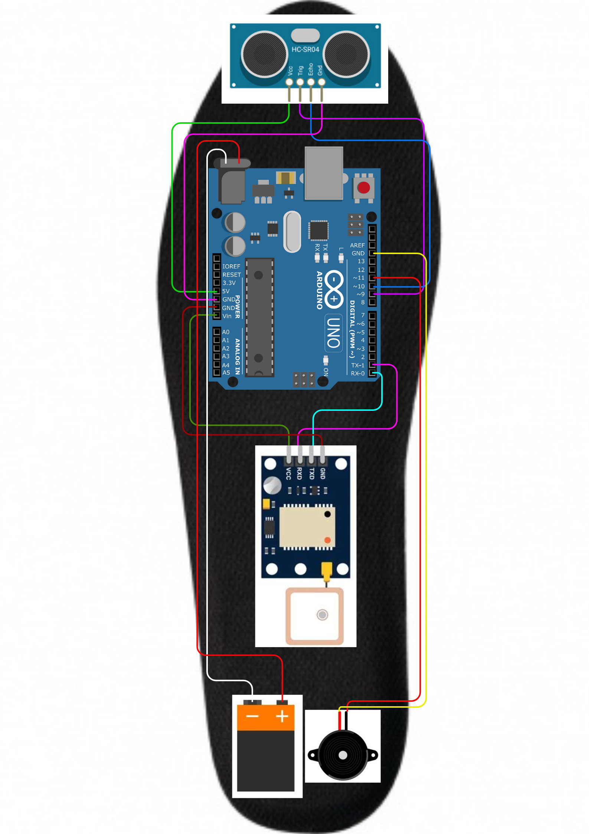

**Project Images**